Annual Report 2019

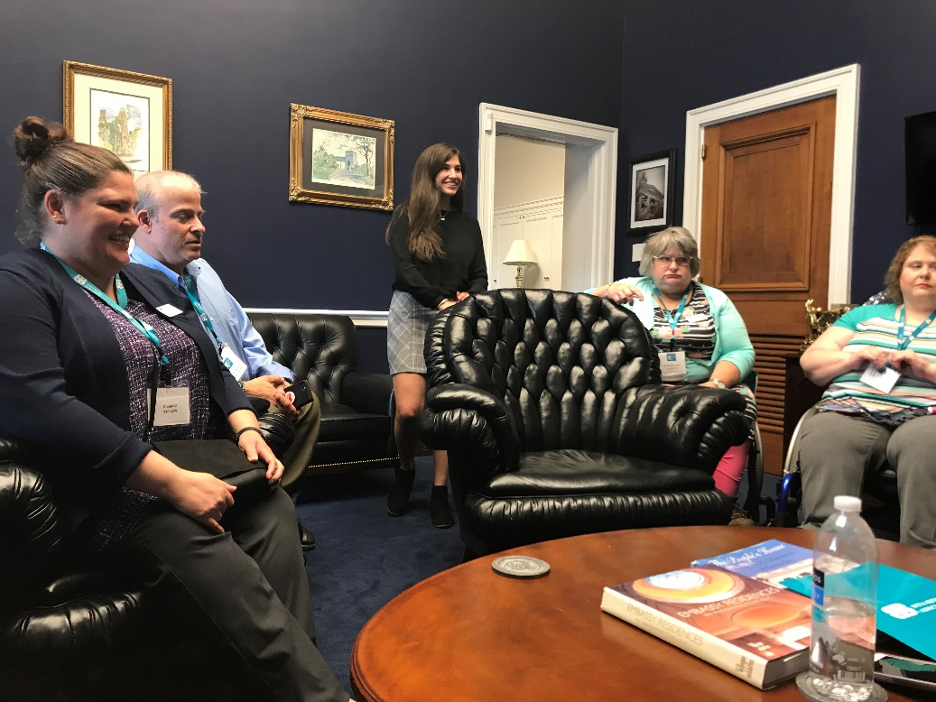
Teal on the Hill – National Advocacy Day

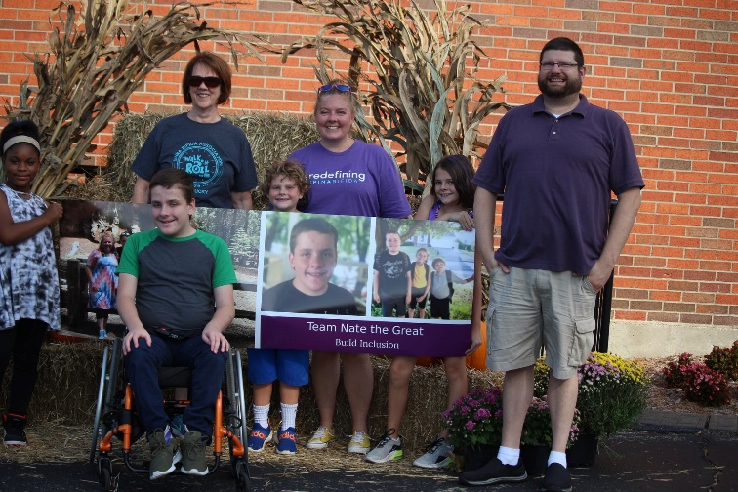

Walk N Roll

Mission
The mission of the Spina Bifida Association of Kentucky is to build a better and brighter future for all those impacted by Spina Bifida.
History
The Spina Bifida Association of Kentucky's (SBAK) mission is to build a better and brighter future for all those impacted by Spina Bifida. SBAK was founded in 1983 by two mothers of children affected by Spina Bifida, who were searching for a support and resource network for families. Over the past 36 years, SBAK has evolved into a thriving and successful organization helping both children and adults affected by Spina Bifida in every corner of The Commonwealth and Southern Indiana.
Over the past eight years, SBAK has grown as an organization to meet the growing and ever-changing needs of our families across Kentucky. In 2011, the addition of an SBAK Lexington office allowed us to increase program outreach efforts in Eastern Kentucky where the rate of neural tube defects is the highest in the nation.

Because The Spina Bifida Association of Kentucky is the only organization in the state that focuses solely and deeply on all issues related to Spina Bifida, we are highly effective in reaching a receptive audience.

The accomplishments and growth of SBAK are the direct result of the commitment, enthusiasm and dedication of many supporters. In 2020, SBAK looks forward to reaching more individuals living with Spina Bifida, their families’ caregivers and supporters. The Spina Bifida Association of Kentucky can accomplish all that we do because of the donation of time and dollars from individuals like you.

Spina Bifida Facts
- Spina Bifida means “split spine.”
- Spina Bifida is a neural tube defect that happens in the first 28 days of pregnancy.
- One out of every 1,300 babies born in the United States each year have Spina Bifida.
- In Kentucky, more than two out of every 1,300 babies are born with Spina Bifida.
- Spina Bifida is the most common permanently disabling birth defect.
- The effects of the Spina Bifida vary from minor back problems to paralysis, hydrocephalus, learning issues and bowel and bladder dysfunction.
- Research studies indicate that if a woman takes 400 mg of folic acid, a B vitamin, daily before becoming pregnant and during the first three months of pregnancy, the number of births involving Spina Bifida could be reduced by 70 %.

ACCOMPLISHMENTS

In this year the Spina Bifida Association of KY intensified efforts to support individuals living with Spina Bifida, their families, friends, caregivers and the professionals who work with them. In addition, SBAK also seeks to educate the public about Spina Bifida. During 2019, SBAK has:
- Collaborated with other organizations and other interested partners to serve the needs of the Spina Bifida Community.
- Educated the public, physicians and other health professional about Spina Bifida.
- Operated support services to assist individuals with Spina Bifida, their families and caregivers.
- Advocated for public policies that increase government funding for Spina Bifida research, education programs, and support services.

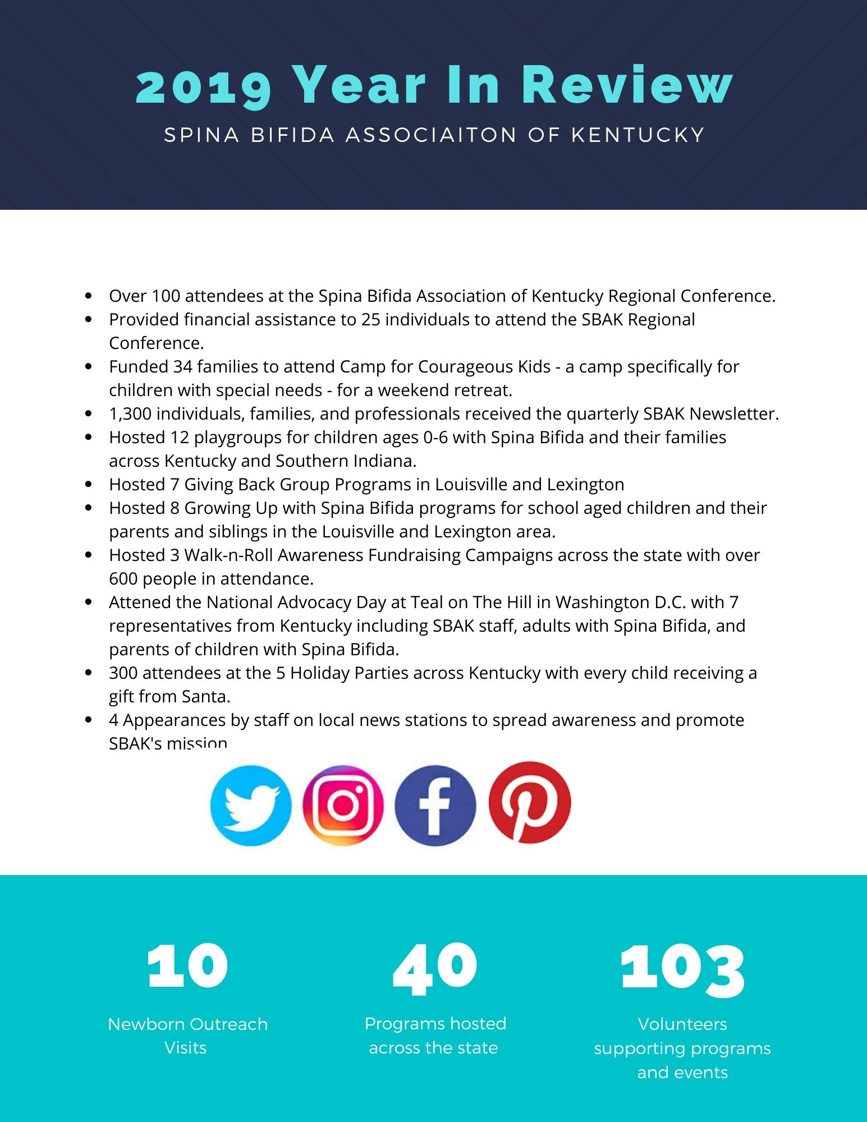

Financial Report*
2019 Income: Where does the money come from? (unaudited)
Fund Raising Events | $66,035
Grants and Partnerships | $66,466
General Donations | $38,661
In-Kind Donations | $14,880
Program Revenue – Conference | $2,732
Interest Income and Sales | $575
Total | $189,349
2019 Expenses: Where does the money go? (unaudited)
Programs & Services | $170,233
Fundraising | $24,967
General/Administrative | $31,777
Total | $226,977
Net Assets Beginning of 2019 | $127,574
Net Assets end of 2019 | $89,946

*Complete copy of our audited financial statements is available on request.

2019 Board of Directors

Amy Sugg
Board Chair
Norton Children’s Hospital - 231 E Chestnut St, Louisville, KY 40202
Director of Operations

Lance Williams
Board Treasurer
Blue and Co. - 2650 Eastpoint Pkwy Suite 100, Louisville, KY 40223
Senior Accountant

Cindy Pryor
Board Secretary
Program Committee Chair
Administrative Assistant II
Humana – 515 W. Market Street, Louisville KY 40202

Erin Straub
Board Member
Summit Financial Group
Operations Process Director/Manager
3108 Setting Sun Court, Crestwood, KY 40014

Colleen Payne
Board Member
6612 Rockview Way, Louisville, KY 40299
MS, MRC

Beth Bryant
Board Member
Adult with Spina Bifida

Michelle Gerken
Board Member
Eastern Kentucky University - 521 Lancaster Ave, Richmond, KY 40475
Associate Professor, EKU

Belinda Coyle
Board Member
Coloplast - Traveling Sales (no office)
Territory Manager KY/IN

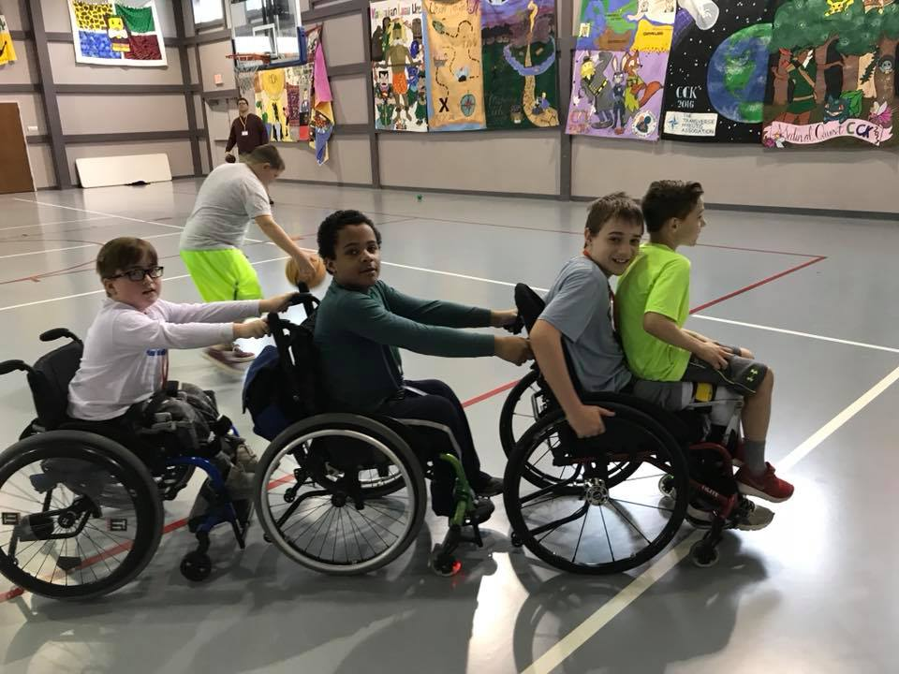

Spina Bifida Family Camp at Center for Courageous Kids

Spina Bifida Association of Kentucky
982 Eastern Parkway, Box 18 Louisville, KY 40217
Office: 502-637-7363 Fax: 502-637-1010

sbak.org

The Spina Bifida Association of Kentucky is a registered 501 (c) 3 organization.
You can donate at sbak.org. All donations are welcomed and tax deductible.
SBAK is supported by generous individual donors, corporate sponsors, matching gifts, grants and
fundraising events.

